38.70: a)
b) 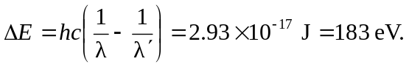
This will be the kinetic energy of the electron. c) The kinetic energy is far less than the rest mass energy, so a non-relativistic calculation is adequate;
